Valencia College
HUM1020: Introduction to Humanities
Spring 2017: ONLINE Syllabus

Instructor: Alberta A. Harris
Email: Use the Blackboard online course mail (best way to reach me)
College email: aharris70@valenciacollege.edu (if Blackboard is down)
Phone: (727) 514-2351 (emergencies only)
Text: Landmarks in Humanities, Special Edition for Valencia College, by Gloria K. Fiero, ISBN # 978-0-07-769560-6, 2017.
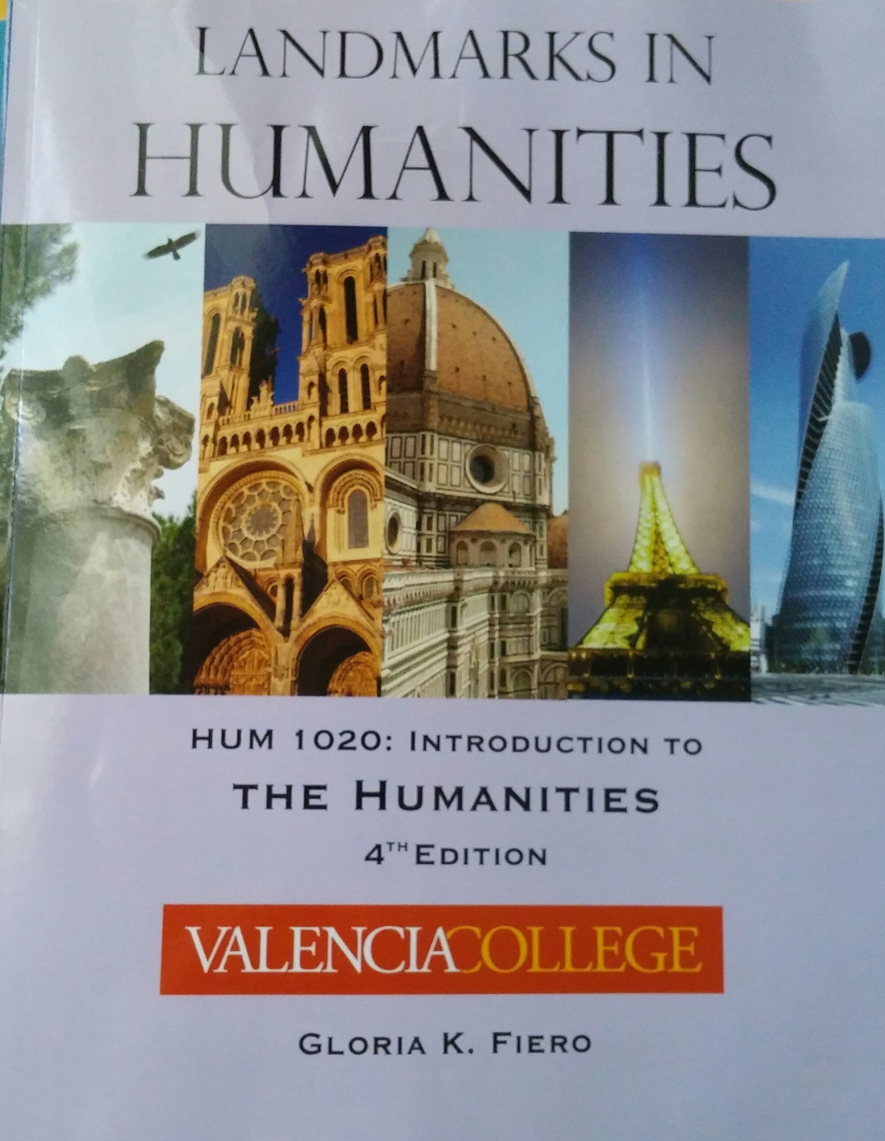

Recommended: MLA Handbook for Writers

Videos online (required to view and for homework) accessible on the Home Page and in each unit, or at http://www.learner.org/resources/series1.html

Companion Website:
http://highered.mcgraw-hill.com/sites/0073376647/information_center_view0/
-this website is great for review and study, although it is the regular edition of the book and not the Valencia edition. Nothing is required from this website. It is for your enrichment only.

Course Overview: Basic introduction to the humanities. Focuses on central concepts, historical development and fundamental nature of philosophy, architecture, music, religion and art. Concepts from such disciplines integrated with contemporary American culture.
Course Outcomes: By the end of this course, the student should be able to: better participate in the cultural life of the community, articulate connections between the humanities and one’s life, and participate in informed conversation about a work of art, literature or philosophy. This goal will be accomplished through student participation in online lessons, videos, homework, tests, discussion boards, and cultural experiences.
Syllabus: This syllabus is a contract between students and the instructor. The instructor has the right to change or modify the syllabus as necessary during the term. Changes will be provided to students in a timely manner. The student is responsible to log on to the class at least three times a week to obtain additional information or alterations to the schedule, as well as any other pertinent information. Students enrolled in the course agree to comply with the course requirements in order to receive a passing grade.

Office Hours: Students may contact the instructor by email or phone, and there may be online office hours as needed.

Assessments:

Writing Assignments: Each unit will have one short writing assignment about a topic we have studied. These assignments involve writing a well-developed paragraph and will be graded according to the criteria provided in the instructions and on the Grading Rubric.

Discussion Boards: For each unit, there will also be a discussion board (see details below), with thoughtful original postings and responses, which will be graded according to the rubric found in the Course Introduction and Overview section of the course.

Exams: There will be a total of four exams given, found in the Exams folder on the homepage or under the Assessments tab. These exams will be based on the lessons, homework, discussion boards and online videos. Tests will include objective questions and identification of art and will have a time limit. All TESTS WILL BE TAKEN USING RESPONDUS LOCKDOWN BROWSER. If you don’t have it, there are instructions in the test folder on the homepage for a free download and also on ATLAS. You will not be able to take the exams without this.

Homework: Students will be required to do online homework, found by clicking on the Assessments tab or in each Unit folder. You will have one attempt to submit the homework, with an unlimited amount of time during that one attempt. You may save the homework and come back to it later also. Out of all the homeworks, the lowest homework grade will be dropped.

Technical Problems: For any log-on or technical problems, contact the Technology Help Desk. There is a link to the helpdesk in the menu on the left of the homepage. Technical problems are not an excuse for incomplete work.

Grading Scale:
Writing Assignments 10%
4 Exams 60%
Homework 25%
Discussion Boards 5%
Study Guides no points (study use only)

A = 90-100 percent D = 60 to 69.9 percent
B = 80 to 89.9 percent F = 59.9 percent or below
C = 70 to 79.9 percent
(Grades will not be rounded up or down. For example, 79.6 equals a “C” grade)

Attendance/ Absence Policy:
Regular attendance is required for all Valencia College courses, including online courses. Students are allowed four absences during the semester. On the fifth absence, the student will automatically be withdrawn from the course by the instructor. Attendance will be taken on every day an assignment of any kind is due. This includes exams, homework, discussions, and any other work assigned in the course. A student will be marked absent if: he or she fails to submit work due that day, or if he or she does not take the last exam in the course. Missing four days of work will be excused; however, on the fifth day, where no work is submitted, the student will be withdrawn. The attendance records of the instructor, not the recollections of the student, will demonstrate proof of attendance. This is just as binding as attending a class in person. Financial aid may also be affected as follows:

Title IV Federal Repayment. You must attend class through 60% of the term.
Failure to do so may require you to repay all or a portion of your Title IV Financial Aid (Pell, SEOG, and Stafford Loans) to the Federal Government
and/or to the College. If you have questions, contact the financial aid office on your campus.
Please see online college calendar for holidays, Drop/Add dates, last day to withdraw or change to audit, other days the college may be closed, or pertinent information.

Withdrawals: If the student decides not to complete the course, it is his or her responsibility to withdraw before the official date. Please review the withdrawal, audit, incomplete, and repeat course policies in the College Catalog and Handbook.
Some Important Dates: Classes begin: Jan. 9, 2017
Last day to drop with refund: Jan. 17, 2017
Last day to withdraw with a “W” – March 31, 2017
No Classes: Jan. 16: Martin Luther King, Jr. Day
March 13-19: Spring Break
Last Day of Term: April 30, 2017

PLEASE NOTE: Please be aware that due to new federal regulations, any student who does not complete an assignment or academic discussion in the first week of class will be withdrawn from the class and is at risk of losing his/her financial aid.
You have two assignments due during this time, which are the first homework and first discussion posting, in the Blackboard course, that qualify for attendance purposes. If neither of these is completed, you will be removed from the class in the No-Show reporting period.

Students with Disabilities: I wish you to have every opportunity to learn and participate in this class. Therefore, if any student has any hearing, visual, physical or speech impairments, or any learning disability or impairment, please contact the college’s Office for Students with Disabilities (OSD), and I will make every effort possible to facilitate your learning, upon their instruction.

College policy: "Students with disabilities who qualify for academic accommodations must provide a Notification to Instructor (NTI) form from the Office for Students with Disabilities (OSD) and discuss specific needs with the professor, preferably during the first two weeks of class. The Office for Students with Disabilities determines accommodations based on appropriate documentation of disabilities. Please contact your campus for more information."

Equal Access/Equal Opportunity Commitment
The college is committed to providing equality in educational and employment access and opportunity without regard to race, color, gender, age, religion, marital status, disability, or national origin. Harassment in any form will not be condoned or tolerated by the College, whether directed toward the employers, employees, or students.

Summary of Major Assignments

Plagiarism or cheating of any kind is not tolerated and will be cause for automatic failure. See section on plagiarism in MLA Handbook and on academic dishonesty in the College Catalog.

PLEASE NOTE: Writing Assignments, Homework, Postings, Responses and Exams may NOT be submitted after the due dates. NO LATE WORK IS ALLOWED. Work may be completed early.

Exams (60% of grade):
- There will be 4 major exams in this course.
- These exams will be based on the readings, lessons, and homework, and will be objective questions in a variety of formats (multiple choice, fill-in-the-blank, image identification, etc.).
- All exams will be online. You will have one timed attempt in which to take the exams. Do NOT log out or go over the time limit, which is indicated on each exam. You will need Respondus Lockdown Browser, which is a free download under the Tools tab in the course or from Valencia College website, or ATLAS. I also provide a direct link in an announcement.
- No late exams are given. If not taken in the time slot allowed, a zero will be recorded.

Homework Assignments (25% of grade):
- Homeworks are due as indicated on the calendar by 11:30 p.m.
- Late homework assignments are not accepted. Any work not submitted on time will receive a zero.
- Some weeks there will more than one chapter or assignment due. Each assignment counts as a separate grade, and all are required. Be sure to read the Introductions to each unit, as much information is given there.
- Readings for the Writing Assignments for each unit come from the assigned readings in the Literature Packet found under Course Content in the course. The prompts for the writing are in the Writing Assignments folder under Course Content.
- The lowest one homework grade of all assigned will be dropped.
- Technical Problems: For any log-on or technical problems, contact the Technology Help Desk. There is a link in the menu bar on the left of the course pages. Technical problems are not an excuse for incomplete work.
- For study purposes, you may access the homework material by clicking on the “Homework After the Deadline” link in each unit. These cannot be submitted for credit but may be used for practice, as they are not
connected to the grade book. They are the same as the original assessments, so you have them for review.

ONLINE VIDEOS: There are several videos that you will watch and for which there
will be homework. The link is provided on the homepage, in each unit, and may also be accessed through the Web Links link on the left of the Homepage. You may also access them at http://www.learner.org/resources/series1.html - Art of the Western World. These videos are required and will help your understanding of the different time periods we study. Test your equipment early to make sure you can access them. Technical problems are NOT excusable.

Writing Assignments (10% of grade):
- Each unit will have one short writing assignment related to the reading assigned for that unit. See the Literature Packet under Course Content for readings.
- These assignments involve writing a well-developed paragraph and will be graded according to the criteria provided in the instructions in the Writing Assignments folder under Course Content and on the Grading Rubric.
- NO late writing assignments will be accepted.
- Please view the Instructional video on Paragraph writing for help on constructing your paragraph.

Discussion Boards: Postings/Responses (5% of grade):
- As assigned (see calendar), students will create a posting (at least 5 sentences) through the discussion board. Prompts will be given for each posting.
- Also, each student must respond to two other students’ responses. Each response must be at least three sentences in an academic discussion.
- Grades will be assigned upon completion of all three parts.
- No postings will be graded after the due date. Late postings/responses will earn a zero. The discussion board will remain open after the due date, for review only - no late submissions will be graded.
- Grades will be assigned as indicated in the Grading Rubric (found in the Course Information and Overview folder).
- Initial Introductory posting only requires a posting with no responses needed to other students. All the unit discussions DO require at least 2 responses.

I know this sounds like a lot of work right now, but there is a lot of rich material to cover, and it will be worth the effort. Please refer to the calendar, the Complete Course Schedule, the syllabus, and announcements for due dates. Please do your best and let’s enjoy this semester!

Units: 1 – Chapters 1, 2, 3 and Video 1: Introduction, Ancient World, Greece, Rome
Primary Source Reading: Plato’s Allegory of the Cave

2 – Chapters 4, 5, 6, and Video 2: Middle Ages and Religion
Primary Source Reading: Dante’s Divine Comedy

3 – Chapters 7. 8, 9, 10, 11 (also Introduction to Scientific Revolution
document) and Video 4: Renaissance to Enlightenment
Primary Source Readings: Declaration of Independence and Declaration of
Rights of Man
4 – Chapters 12, 13, 14, 15, and Video7: Romanticism to Postmodernism
Primary Source Reading: Martin Luther King, Jr.’s “Letter from
Birmingham City Jail”

HUM1020 Course Schedule Spring 2017
Please note that on most dates more than one assignment is due, and that the days of the week that assignments are due may vary. All are due by 11:30 p.m.

Jan. 9: Course begins.
Read Introduction to Course and Requirements

Jan. 13: Introduction Homework due over syllabus and course requirements
Initial Posting due- These assignments above do NOT need the book.

Jan. 18: Homework due: Introduction to Unit document in Unit 1 folder
Chapter 1: Origins: The First Civilizations

Jan. 24: Homework due: Chapters 2: Classicism: The Greek Legacy
Plato’s Allegory of the Cave reading homework and
writing assignment

Jan. 29: Homework due: Chapter 3: – Empire: The Power and Glory of Rome
Video 1: The Classical Ideal

Jan. 30-Feb. 2: Exam 1 (Unit 1 Introduction, Chapters 1, 2, 3, Readings, and Video 1)
Feb. 2: Discussion Board Postings and Responses due

Feb. 5: Homework due: Chapter 4: Revelation: The Flowering of World Religions

Feb. 9: Homework due: Chapter 5: Synthesis: The Rise of the West
Video 2: A White Garment of Churches

Feb. 14: Homework due: Chapter 6: Christendom: Europe in the Age of Faith
Dante’s Divine Comedy reading homework and writing
assignment

Feb. 15-Feb. 19: Exam 2 (Introduction to Unit 2, Chapters 4, 5, 6, Readings, Video 2)
Feb. 19: Discussion Board Postings and Responses due

Feb. 23: Homework due: Chapter 7: Rebirth: The Age of Renaissance
Video 4 The High Renaissance

Feb. 26: Homework due: Chapter 8: Reform: The Northern Renaissance and the
Reformation

Mar. 1: Homework due: Chapter 9: The Native American part only-p. 248-251
Chapter 10: Baroque: Piety and Extravagance

Mar. 5: Homework due: Introduction to Scientific Revolution (Be sure to read
Unit Introduction for the Scientific Revolution lesson)

Mar. 12: Homework due: Chapter 11: Enlightenment: Science and New Learning
Declaration of Independence and Declaration of
Rights of Man Readings; Galileo article homework
and writing assignment

Spring Break – Mar. 13-19 (You may take the exam before or during the break if that would be better for you – early exams allowed.)

Mar. 20-25: Exam 3 (Chapters 7, 8, 9, 10, 11, Sci. Rev., Readings and Video 4)
Mar. 25: Discussion Board Postings and Responses due

Mar. 30: Homework due: Chapter 12: Romanticism: Nature, Passion, and the
Sublime

Last Day to Withdraw with a W: March 31

April 6: Homework due: Chapter 13: Materialism: The Industrial Era and the
Urban Scene
Video 7: A Fresh View -Impressionism and Post-
Impressionism

April 11: Homework Due: Chapter 14: Modernism: The Assault of Tradition

April 16: Homework Due: Chapter 15: Globalism: Information, Communication,
and the Digital Revolution
Martin Luther King, Jr.’s “Letter from Birmingham Jail” Reading homework and writing assignment

April 17-23: Exam 4 (Chapters 12, 13, 14, 15, Readings, and Video 7)
April 23: Discussion Board Postings and Responses due

